  - IDEATION PHASE

Empathize & Discover
Date | 29 September 2026
Team ID | 6ab1d50c92b876d9664094bc
Project Name | Auto Ticket Classification Using Flow Designer
Maximum Marks | 4 Marks

Empathy Map Canvas
Target user: IT support agent / service desk analyst who receives and classifies incoming support tickets. The statements below are proposed user insights for the project, not findings from user interviews.
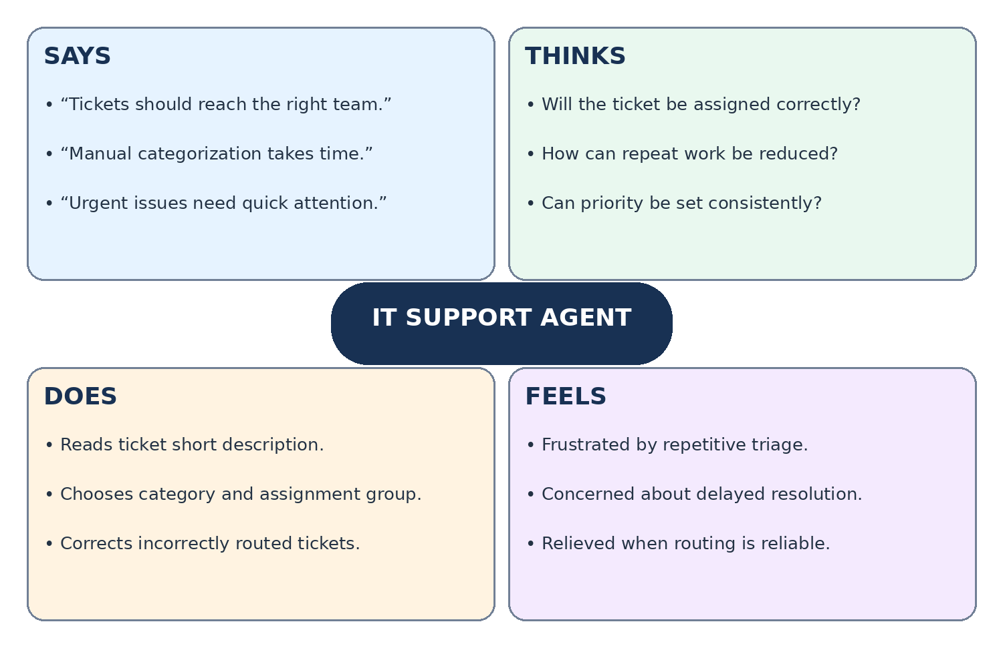

User Needs and Pain Points
Needs: fast, consistent ticket categorization; accurate assignment to the responsible support group; visibility into exceptions and urgent issues.
Pain points: repeated manual review, inconsistent classification, misrouted tickets, and delayed response to high-priority requests.

Proposed Solution: Flow Designer
When a new incident is created in ServiceNow, a Flow Designer flow evaluates its short description and other available fields against defined conditions, sets category and priority where appropriate, and assigns the ticket to a matching support group. Unmatched tickets go to a default triage queue for manual review.

Proposed Ticket Classification Workflow
New incident created
↓ Flow Designer trigger runs
↓ Check keywords and ticket fields
↓ Set category, priority and assignment group
↓ Matched → assigned team | Unmatched → manual triage
↓ Notify assigned group and track ticket
Note: Classification rules and assignment groups are configurable examples; actual values should be finalized with the project team.

